**Hands on- Task 2**

**Name : Podutur Lahari - DE126**

**Date : 05-11-2024**

**1. Implementing Data Integrity**

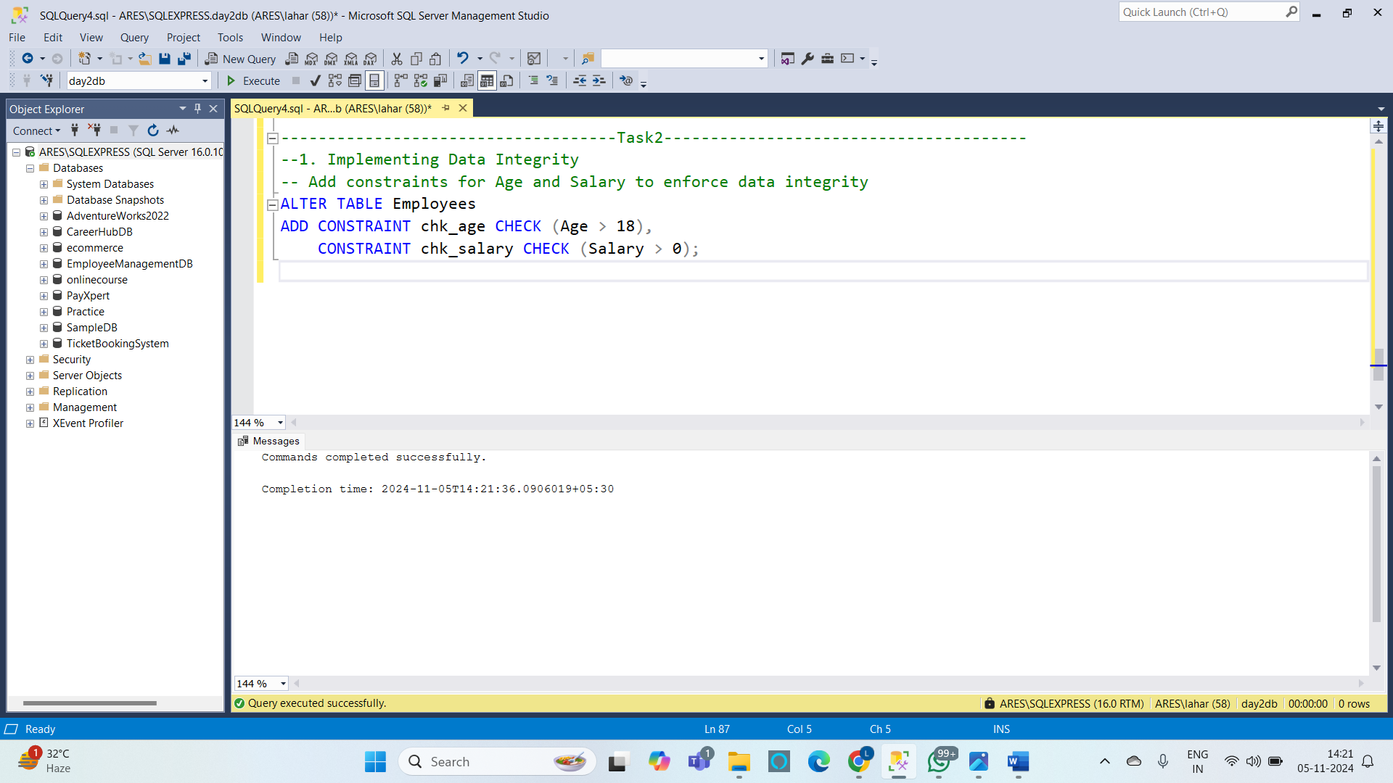

**2. a. Using Functions to Customize the Result Set :**

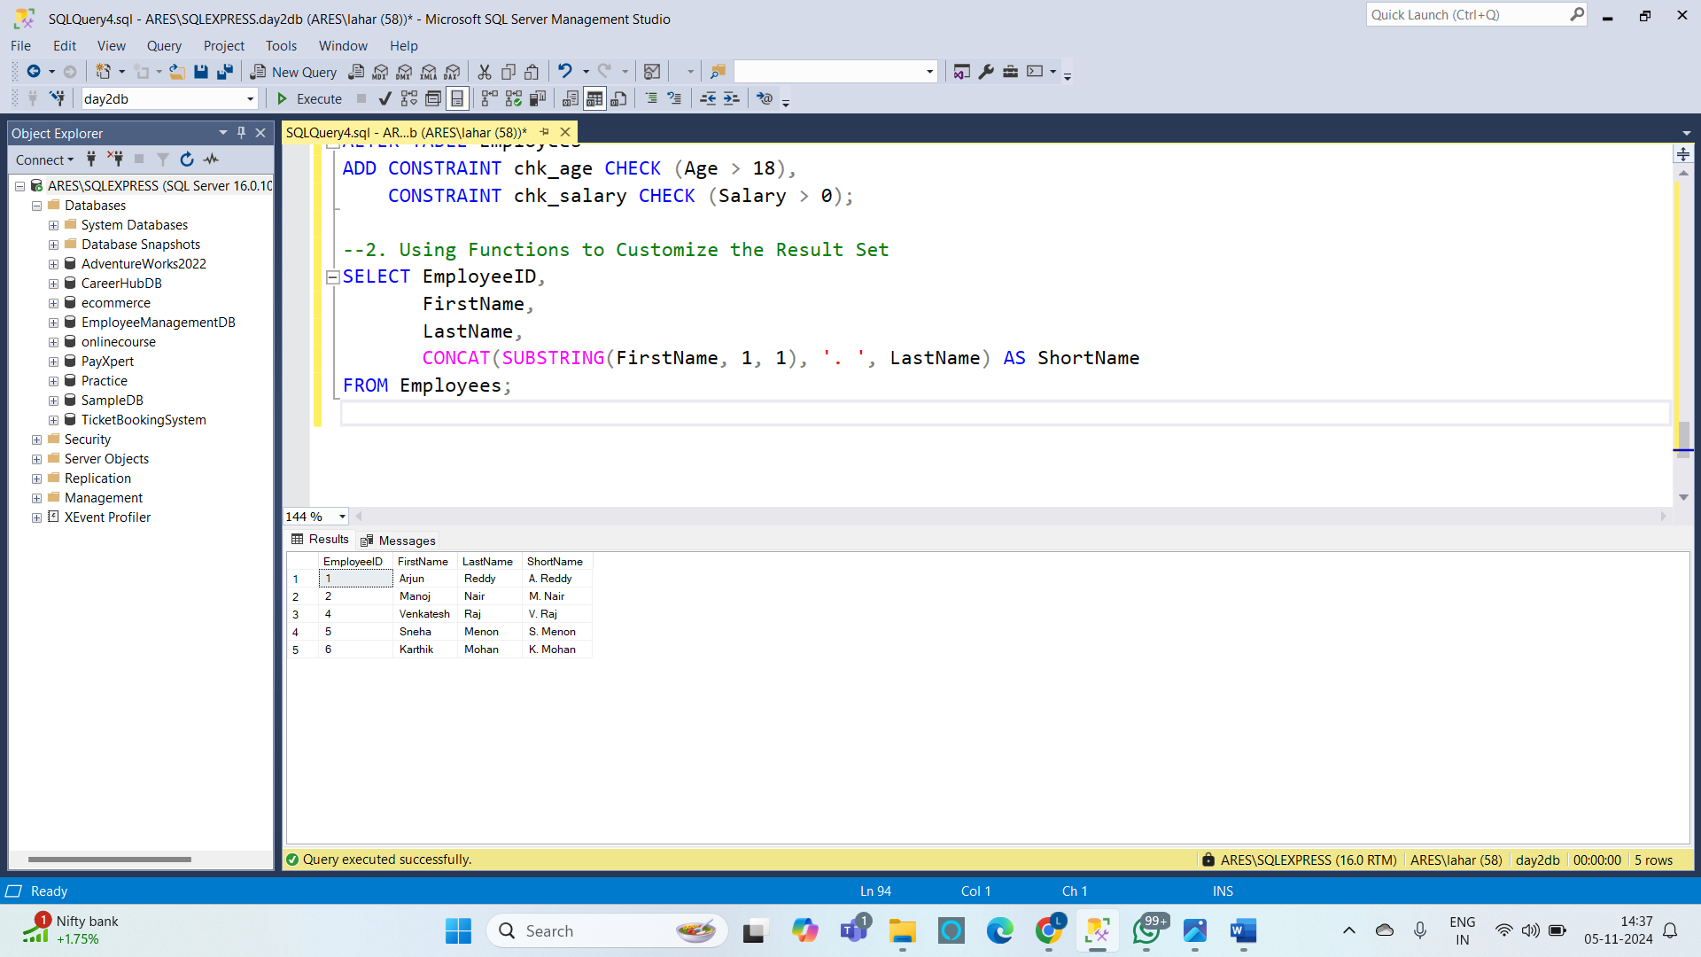

**b. Using Date Functions**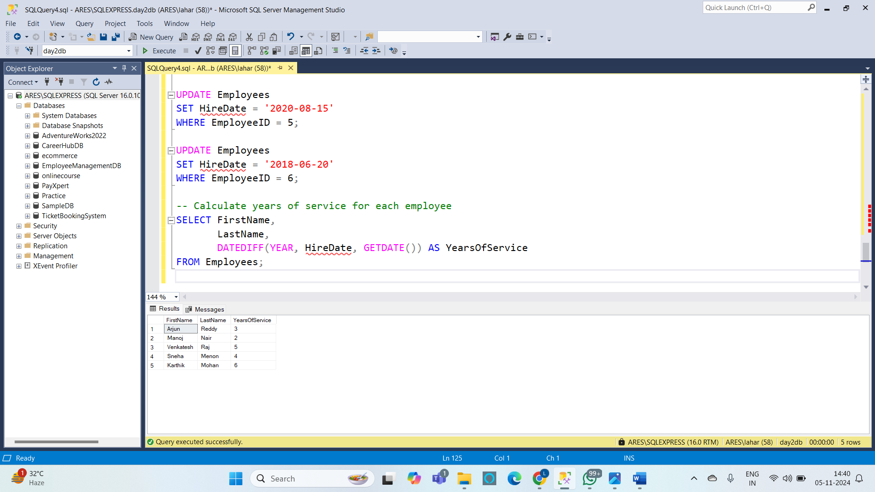

**c. Using Mathematical Functions**

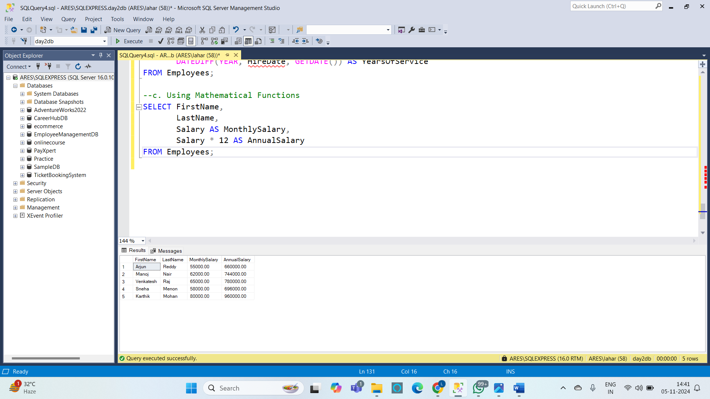

**d. Using System Functions**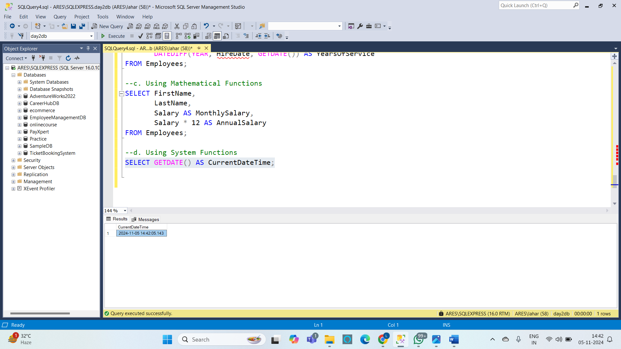

**3. Summarizing and Grouping Data**

1. **Summarizing Data by Using Aggregate Functions**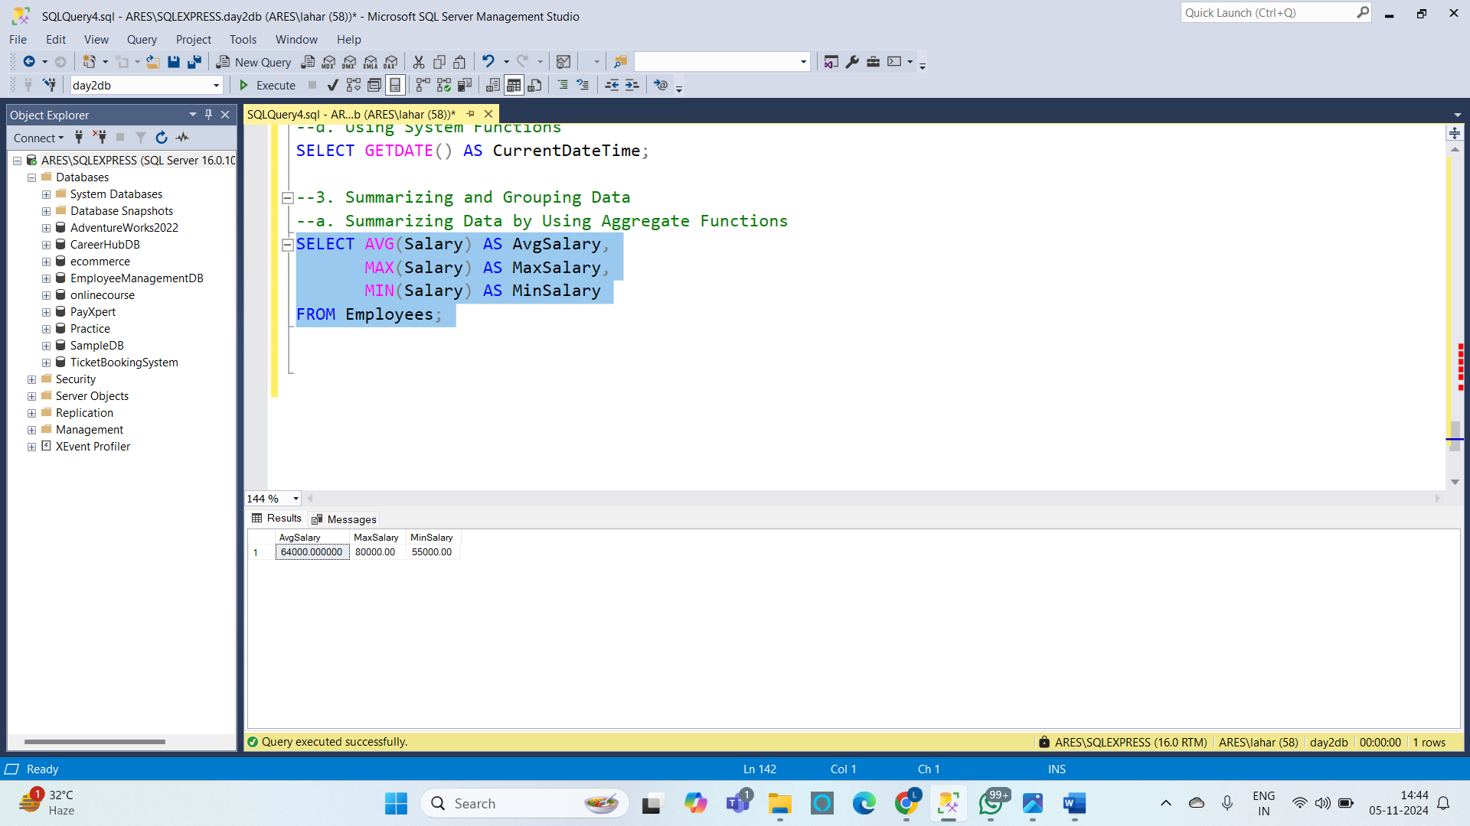
2. **Grouping Data**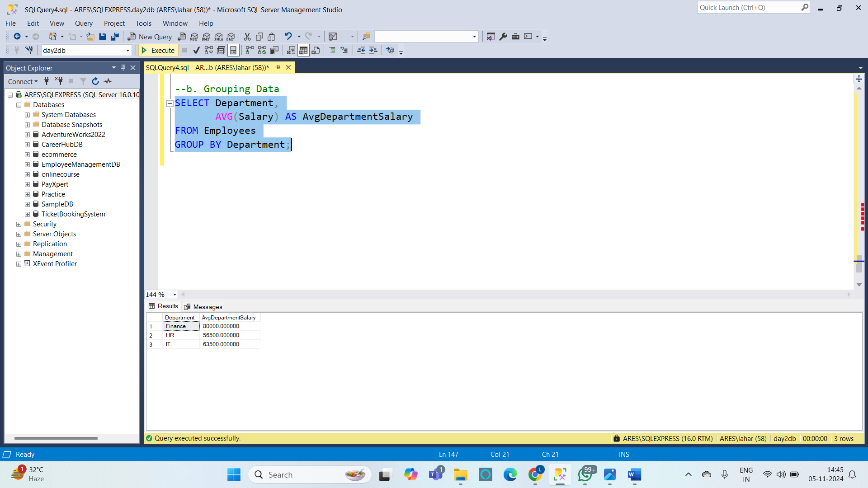

**Hands-on Exercises :**

**1. Filtering Data using SQL Queries**

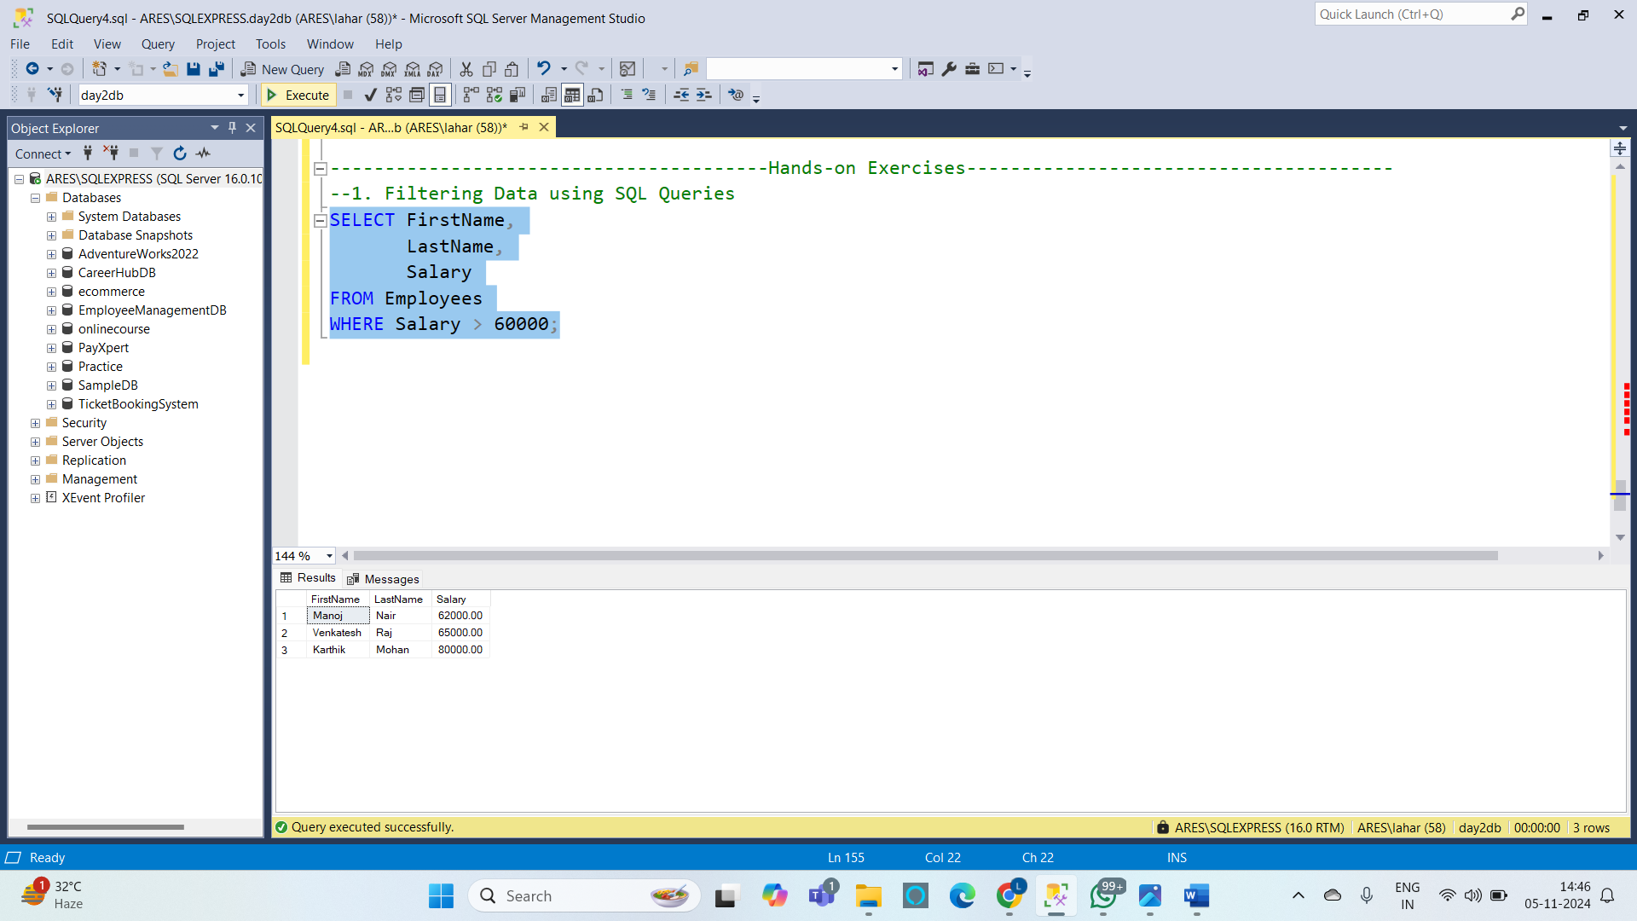

**2. Total Aggregations using SQL Queries**

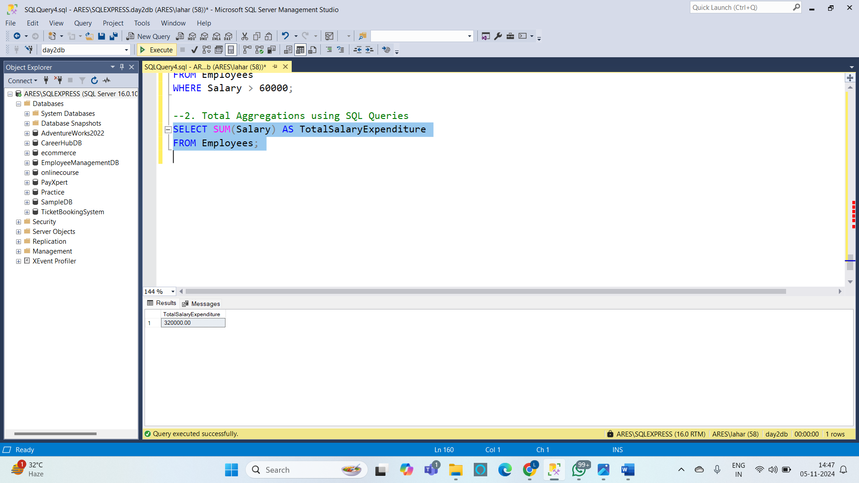

**3. Group By Aggregations using SQL Queries**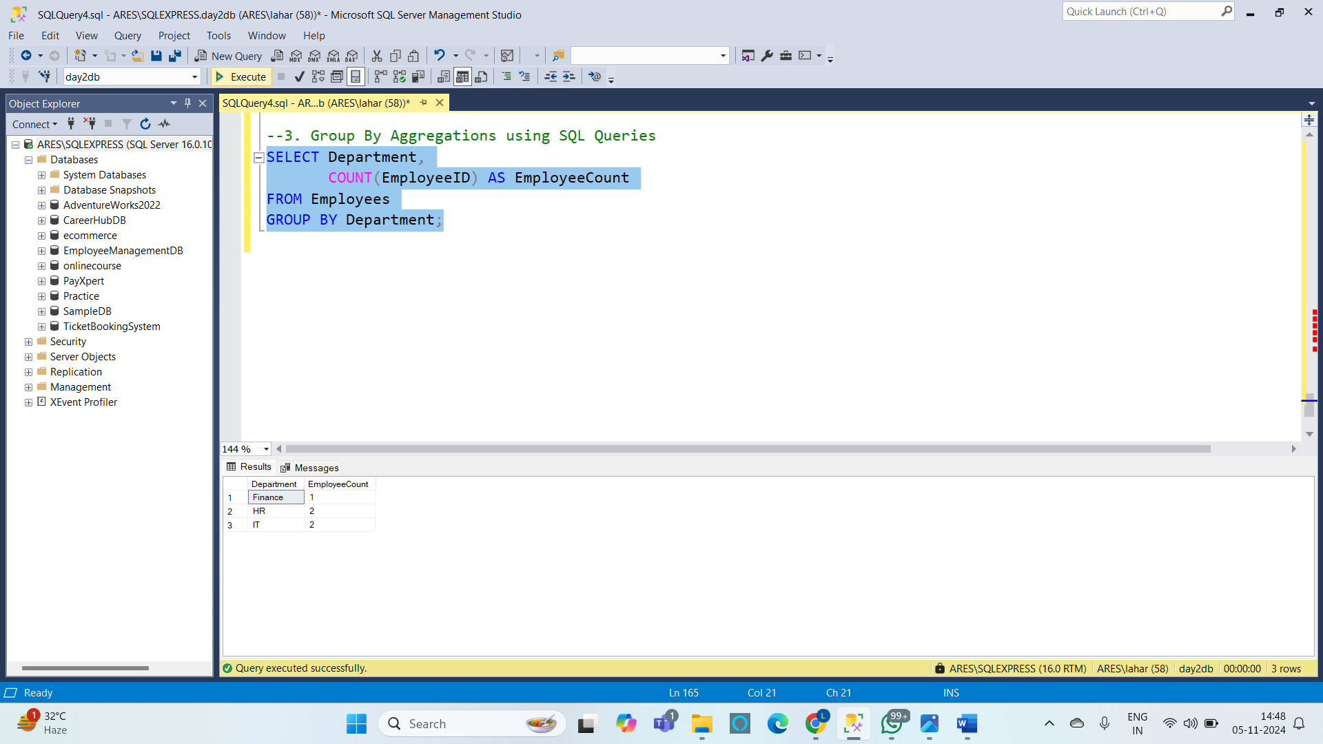

**4. Order of Execution of SQL Queries :**

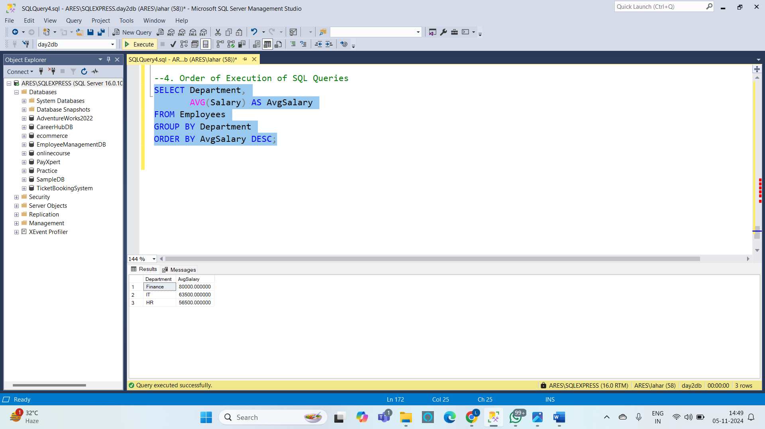

**5. Rules and Restrictions to Group and Filter Data in SQL Queries**

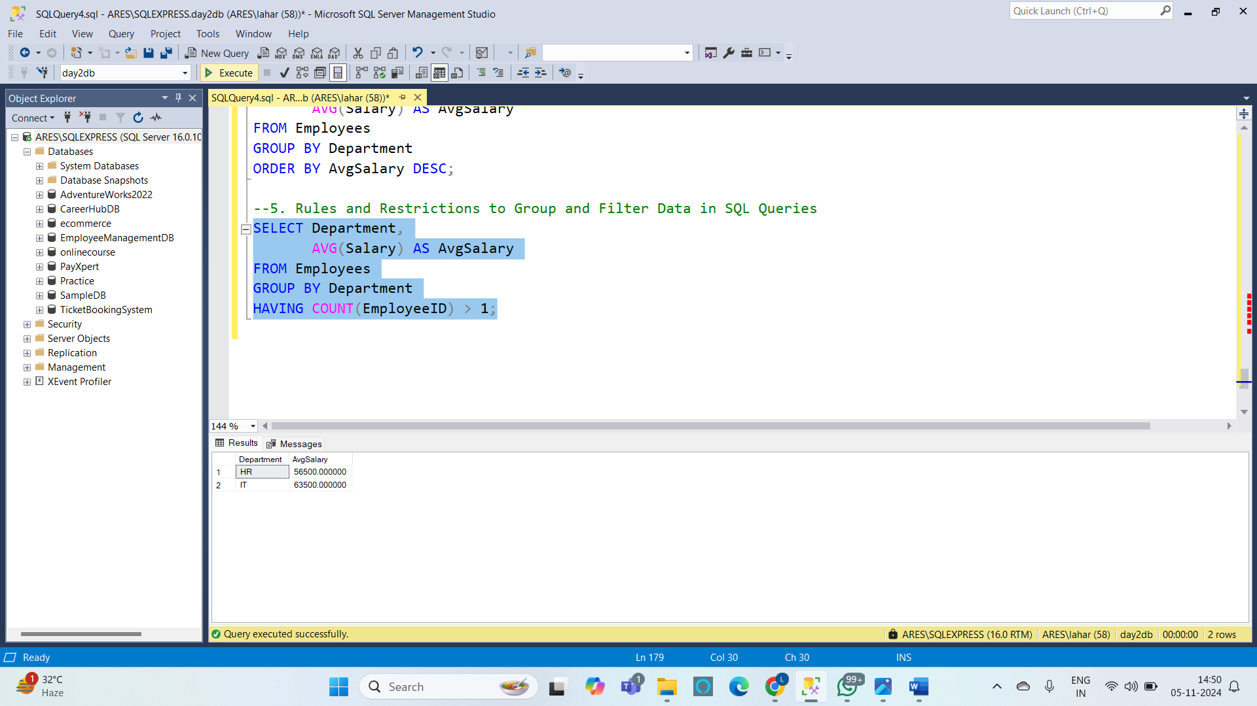

**6. Filter Data Based on Aggregated Results Using GROUP BY and HAVING :** 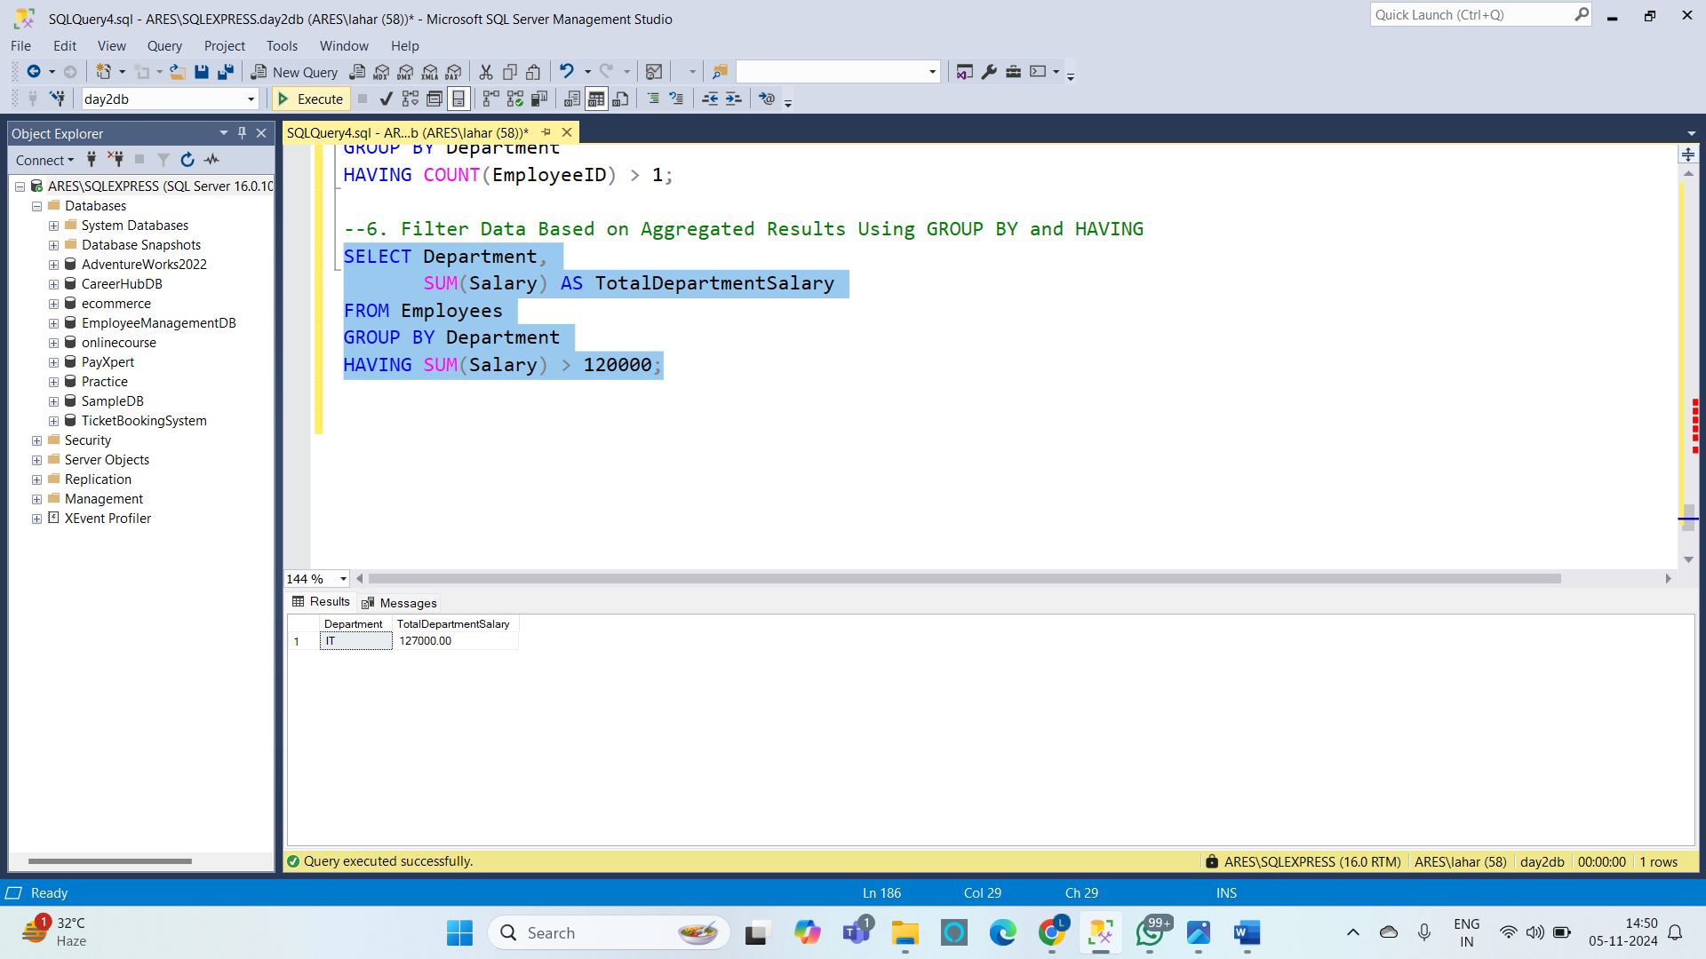

**Code:**

--1. Implementing Data Integrity

-- Add constraints for Age and Salary to enforce data integrity

ALTER TABLE Employees

ADD CONSTRAINT chk_age CHECK (Age > 18),

CONSTRAINT chk_salary CHECK (Salary > 0);

--2. Using Functions to Customize the Result Set

SELECT EmployeeID,

FirstName,

LastName,

CONCAT(SUBSTRING(FirstName, 1, 1), '. ', LastName) AS ShortName

FROM Employees;

--b. Using Date Functions

-- Adding HireDate column with sample data

ALTER TABLE Employees

ADD HireDate DATE;

UPDATE Employees

SET HireDate = '2021-01-10'

WHERE EmployeeID = 1;

UPDATE Employees

SET HireDate = '2022-03-05'

WHERE EmployeeID = 2;

UPDATE Employees

SET HireDate = '2019-07-19'

WHERE EmployeeID = 4;

UPDATE Employees

SET HireDate = '2020-08-15'

WHERE EmployeeID = 5;

UPDATE Employees

SET HireDate = '2018-06-20'

WHERE EmployeeID = 6;

-- Calculate years of service for each employee

SELECT FirstName,

LastName,

DATEDIFF(YEAR, HireDate, GETDATE()) AS YearsOfService

FROM Employees;

--c. Using Mathematical Functions

SELECT FirstName,

LastName,

Salary AS MonthlySalary,

Salary * 12 AS AnnualSalary

FROM Employees;

--d. Using System Functions

SELECT GETDATE() AS CurrentDateTime;

--3. Summarizing and Grouping Data

--a. Summarizing Data by Using Aggregate Functions

SELECT AVG(Salary) AS AvgSalary,

MAX(Salary) AS MaxSalary,

MIN(Salary) AS MinSalary

FROM Employees;

--b. Grouping Data

SELECT Department,

AVG(Salary) AS AvgDepartmentSalary

FROM Employees

GROUP BY Department;

----------------------------------------Hands-on Exercises---------------------------------------

--1. Filtering Data using SQL Queries

SELECT FirstName,

LastName,

Salary

FROM Employees

WHERE Salary > 60000;

--2. Total Aggregations using SQL Queries

SELECT SUM(Salary) AS TotalSalaryExpenditure

FROM Employees;

--3. Group By Aggregations using SQL Queries

SELECT Department,

COUNT(EmployeeID) AS EmployeeCount

FROM Employees

GROUP BY Department;

--4. Order of Execution of SQL Queries

SELECT Department,

AVG(Salary) AS AvgSalary

FROM Employees

GROUP BY Department

ORDER BY AvgSalary DESC;

--5. Rules and Restrictions to Group and Filter Data in SQL Queries

SELECT Department,

AVG(Salary) AS AvgSalary

FROM Employees

GROUP BY Department

HAVING COUNT(EmployeeID) > 1;

--6. Filter Data Based on Aggregated Results Using GROUP BY and HAVING

SELECT Department,

SUM(Salary) AS TotalDepartmentSalary

FROM Employees

GROUP BY Department

HAVING SUM(Salary) > 120000;